  - 2019
  - Annual Report

11th & Bark
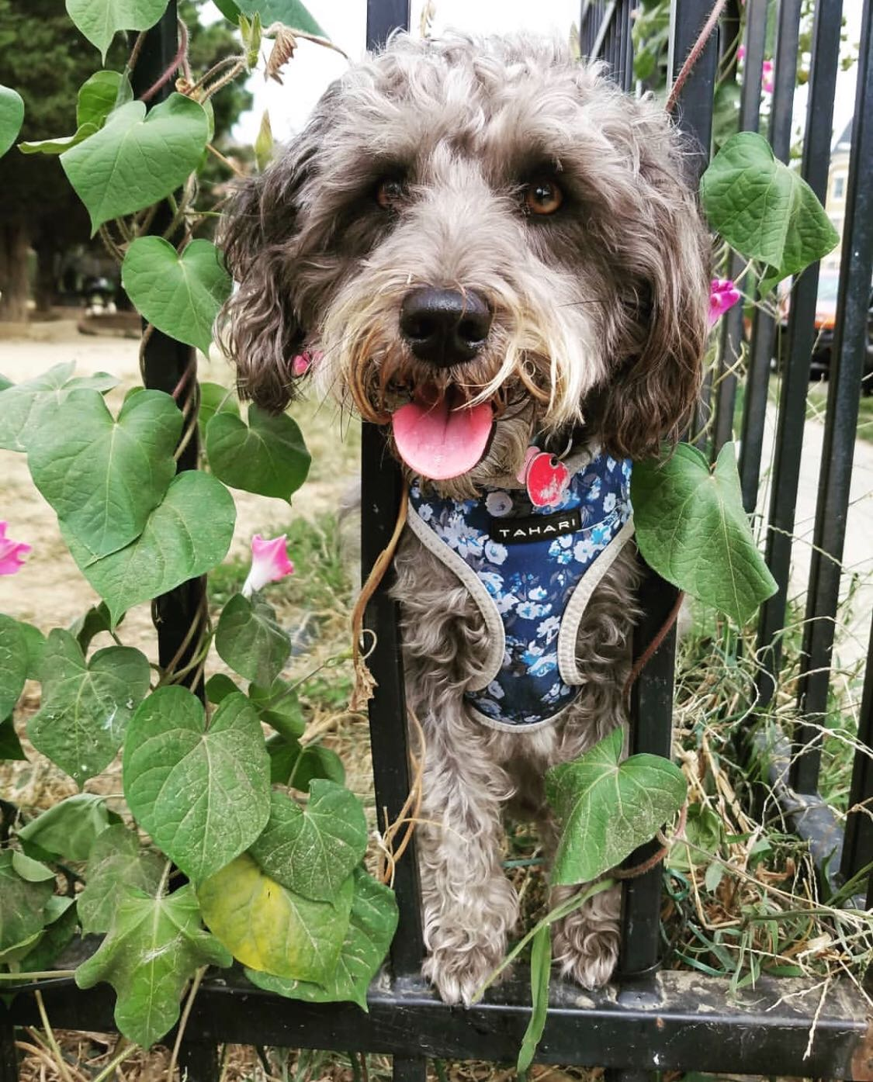
11th & Bark is a 501(c)(3) nonprofit corporation that was formed to make the Columbia Heights Dog Park an official city off-leash dog park. We are a partner of Green Spaces for DC.
We formed in 2015 to work with the District of Columbia to purchase the land, or create a lease agreement with the Washington Metropolitan Area Transit Authority (WMATA), so that we can improve the park. Thanks to advocacy of supporters like you, the District finally began the process of purchasing the park in November 2019, but the fight to save the park isn’t over yet.

Board of Directors
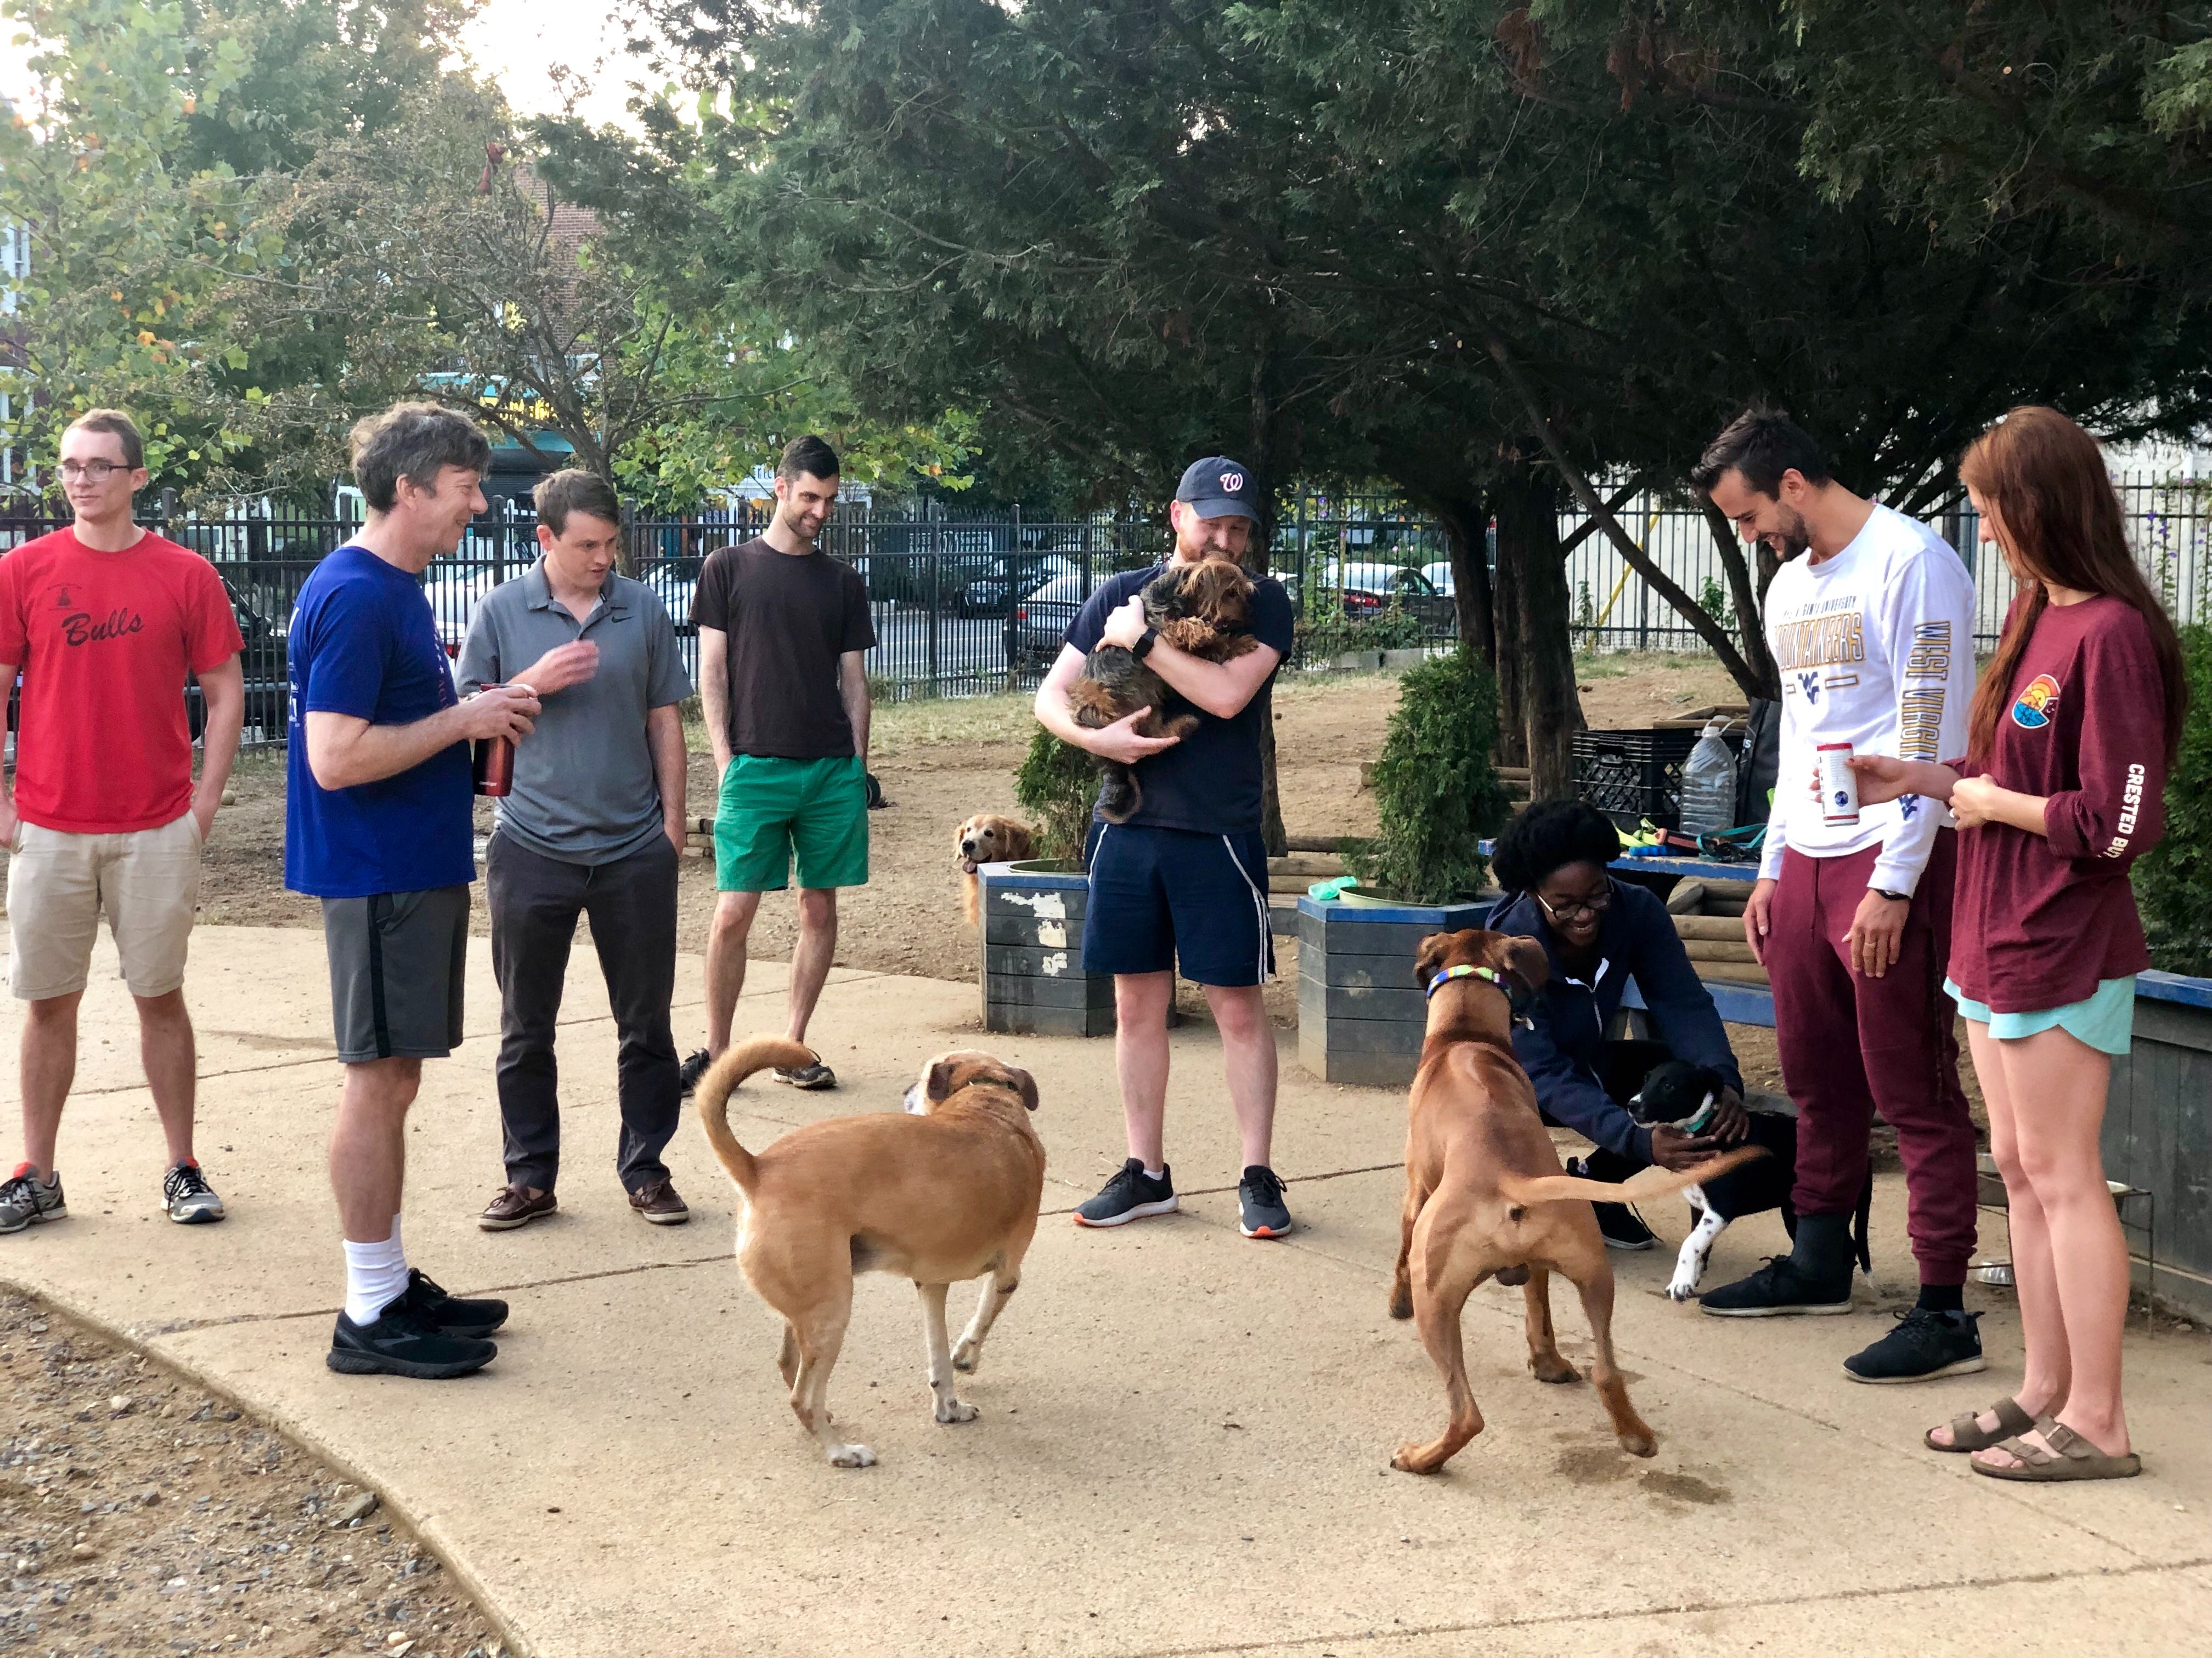

Maggie Garrett, Chair

Cecilie Lindsay, Vice Chair

Eva Guenther, Secretary

Lori Robertson, Treasurer

Baird Wallace, Member

Eric Cuervas, Member

2019 Highlights

At the end of 2018, after a year of community advocacy led by 11th & Bark, the District had allocated money to purchase the park in the FY2019 budget and had made an offer to WMATA. It came as a big surprise, therefore, when a “for sale” sign suddenly appeared in the park in January 2019. Apparently, WMATA rejected the District’s offer and listed the property for sale.

11th & Bark immediately mobilized the community to urge the Mayor to increase the bid for the purchase to ensure it was a fair market value offer. We created an action alert and a new petition to help elevate the voice of the community. The ANC1A supported our efforts, adopting a resolution in favor of a fair market value bid, which was introduced by Commissioner Angelica Castañon (1A06).

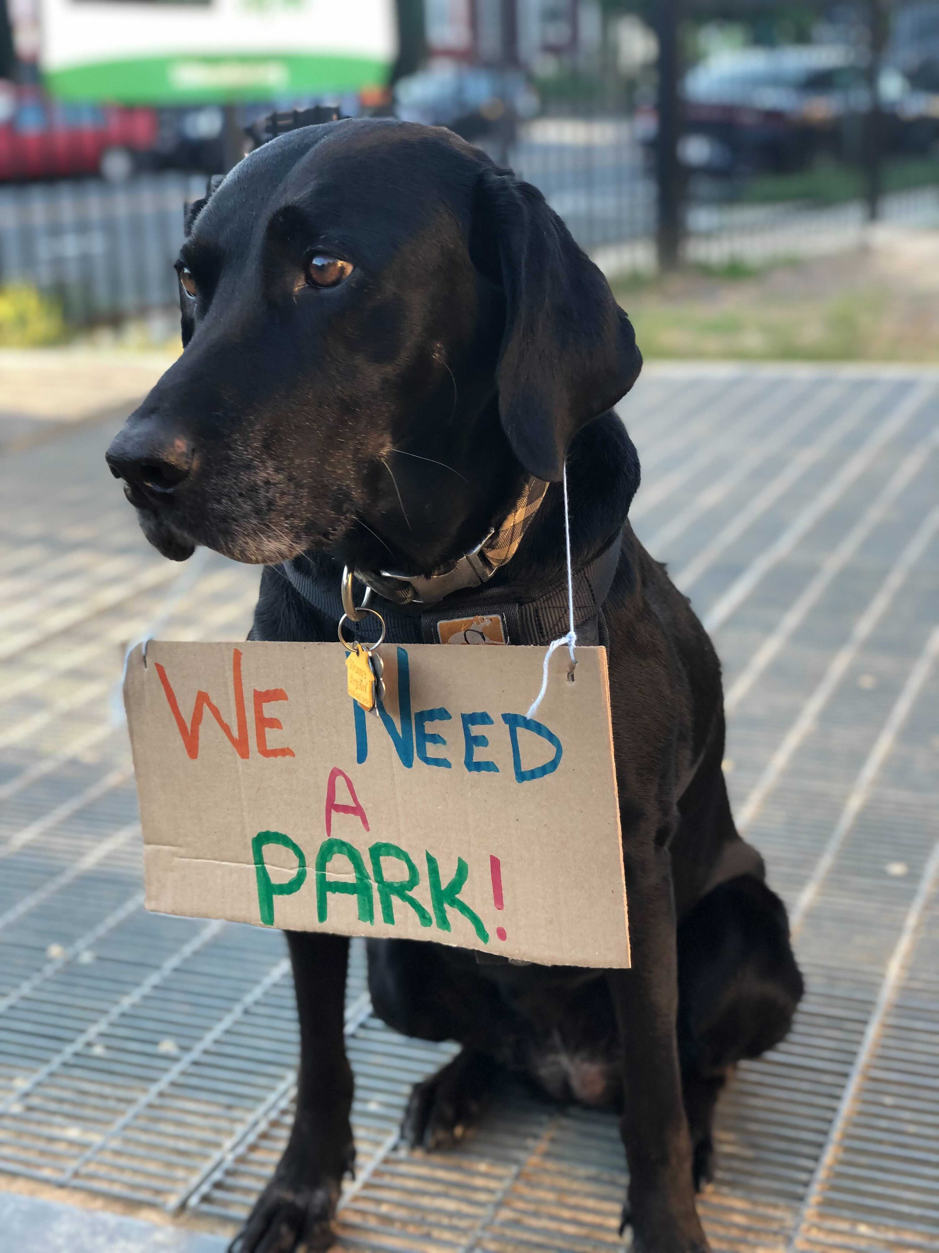
Our efforts were covered by the Washington Post, WUSA9, Biznow, and DC Curbed, among others.

The bid process was supposed to close in February 2019 but remained open through May 2019, when we were informed WMATA accepted a higher bid from a developer. Community discussions then pivoted to whether we could find a new location for the dog park. 11th & Bark was, again, central to this discussion, helping to keep park goers informed and assisting them in telling the ANC they wanted to move our park to another location.
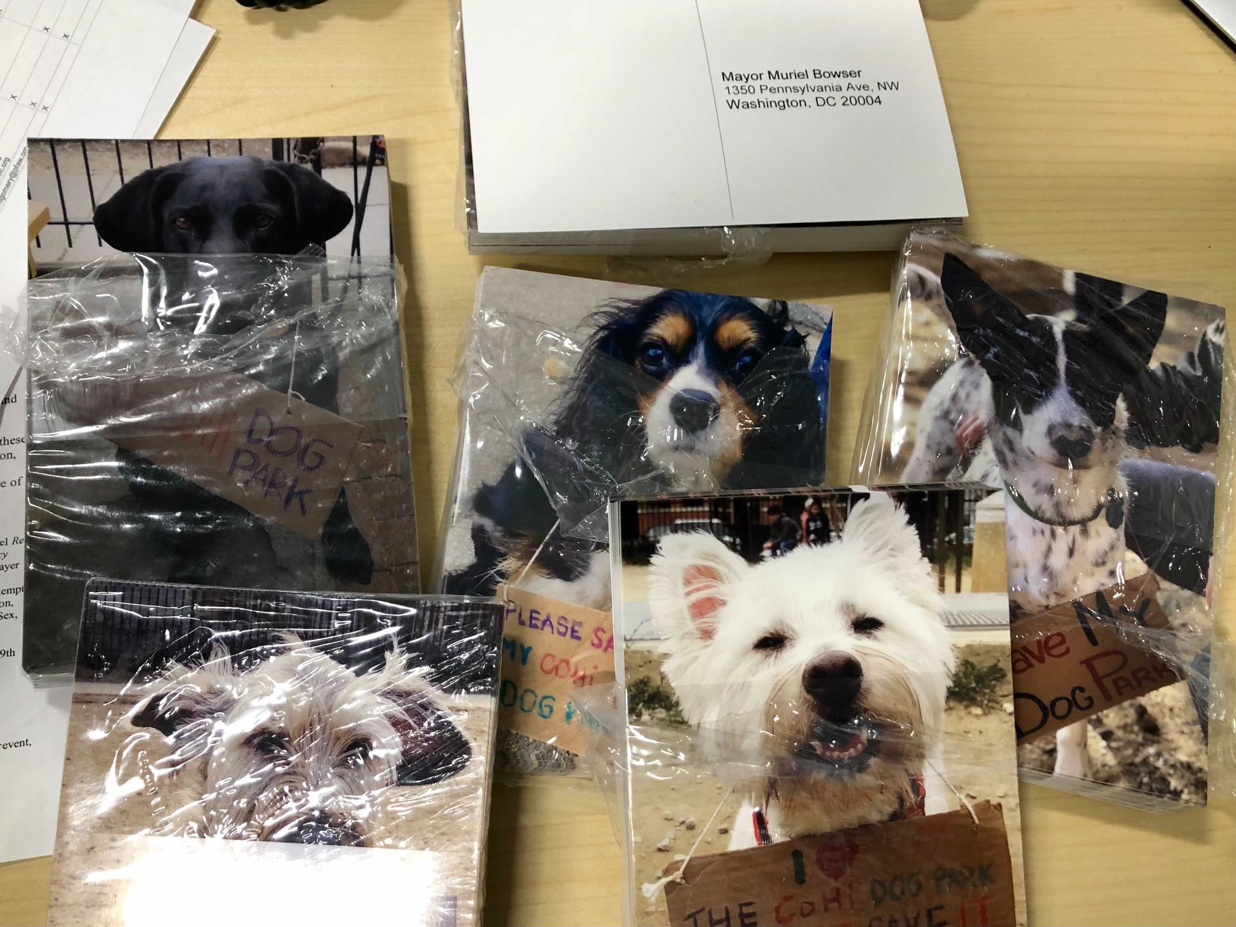
Just a few weeks later at a May 21, 2019 ANC1 Zoning, Planning, and Parks Committee meeting about whether we could relocate the park, Council Member Brianne Nadeau announced that WMATA had changed course, pulled the property off the market and was giving the city an opportunity to buy it. In a letter to Mayor Muriel Bowser dated May 21, 2019, WMATA General Manager and CEO Paul Wiedefeld said WMATA would send a draft purchase agreement to the city by May 31.

Little progress was made by December 31, and we ended the year awaiting news from the District on any progress on the purchase. It was clear, however, that the voice of this community was critical in keeping the dog park open.

Community Events

11th & Bark recognizes that the dog park is about the people and the community. That is why we have put a priority on being a good neighbor, and hosting and joining neighborhood events, including some that have become neighborhood traditions. The highlights from 2019 include:

Mardi Paws
Teaming up with the Community Wellness Alliance, the North Columbia Heights Civic Association, Encounter Church, and Viva the Life to host the 2019 Mardi Paws. The March 9th event included a dog costume contest, prizes, and giveaways. We also collected donations for the Humane Rescue Alliance.

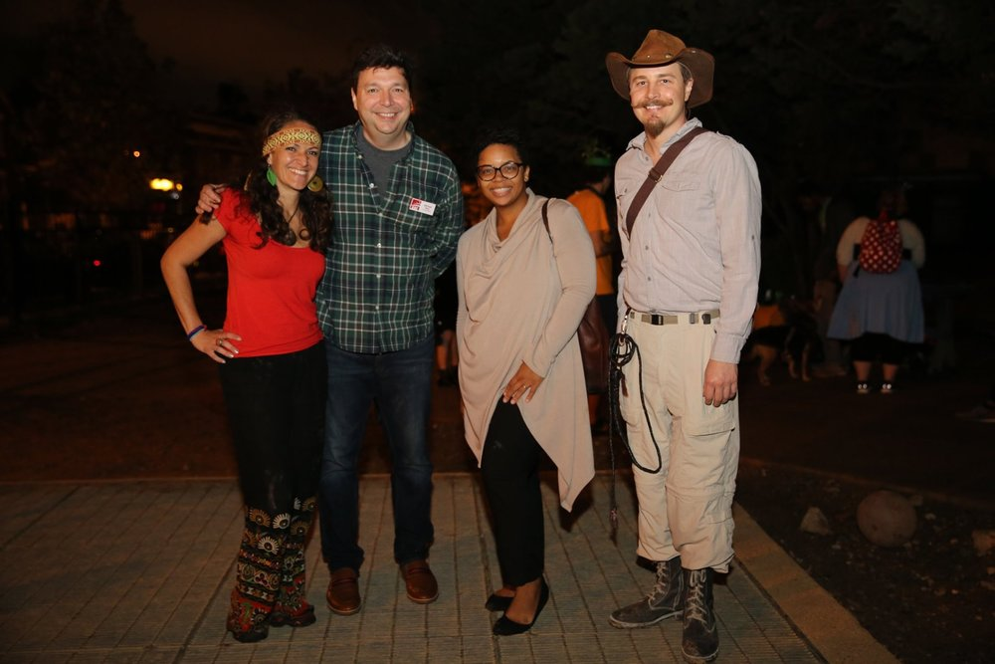
Halloween
Joining the North Columbia Heights Civic Association and other organizations to sponsor the 2019 Halloween Dog Costume Contest at the dog park. Dozens of dogs participated in the event and competed for 1st and 2nd place ribbons in four categories: Scariest, Most Original, Best Human/Dog Combo and Cutest Costume. Our judges were ANC Commissioner Michael Wray, Carolina Buitrago of District Bridges, and Cecilie Lindsay of 11th & Bark. Our MC was Board member Baird Wallace. Lou Vivas helped out with photos and 11th Street restaurant Queen’s English joined in the festivities: they sponsored drinks on their porch and donated 10% of the proceeds from each drink to the park.
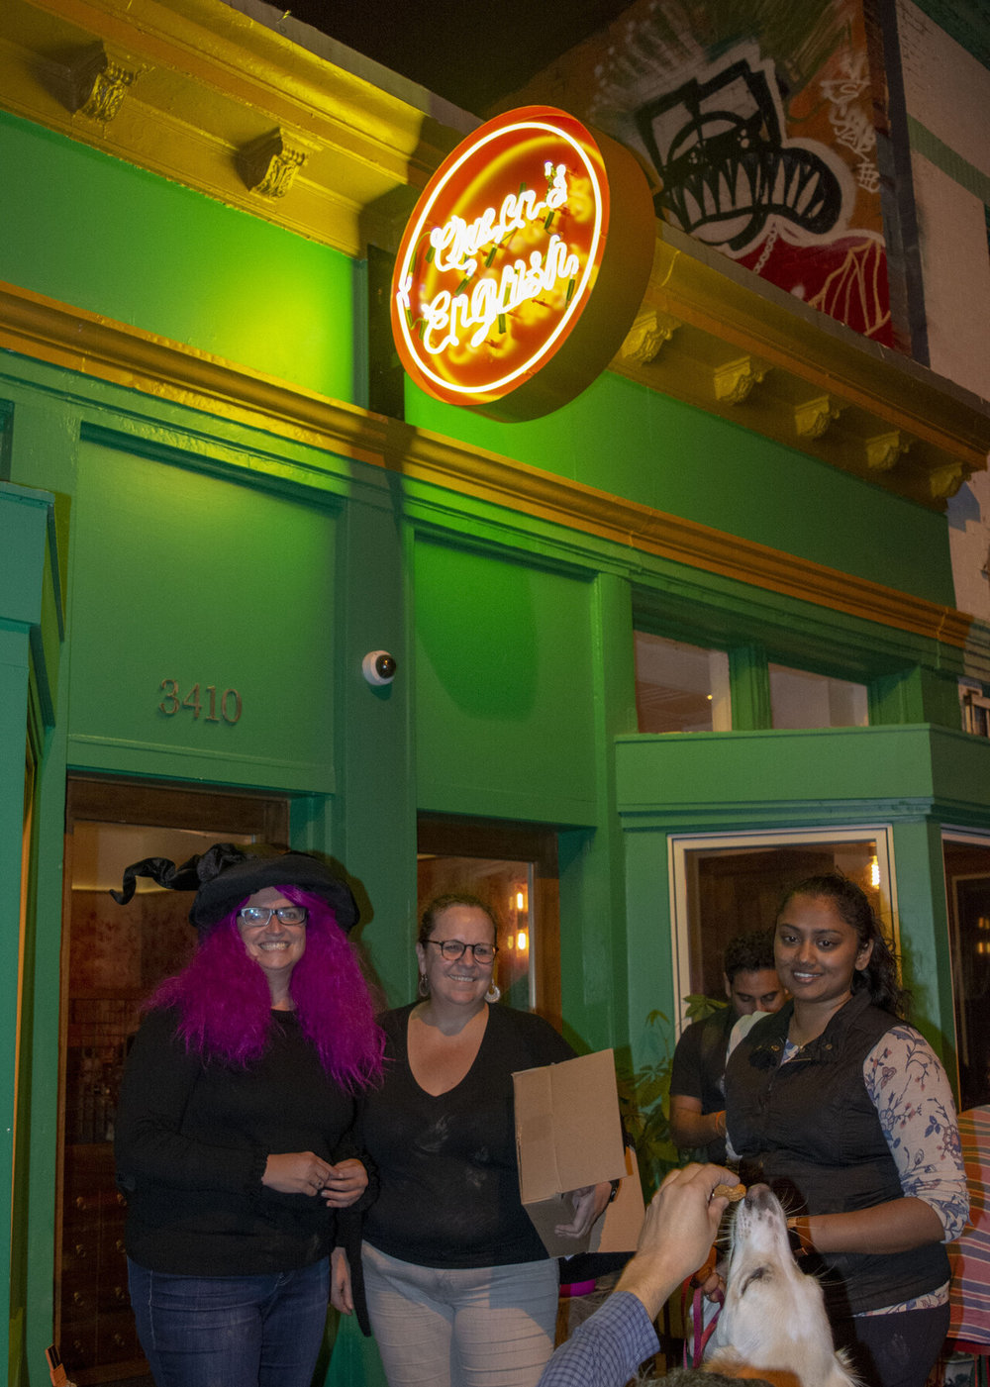
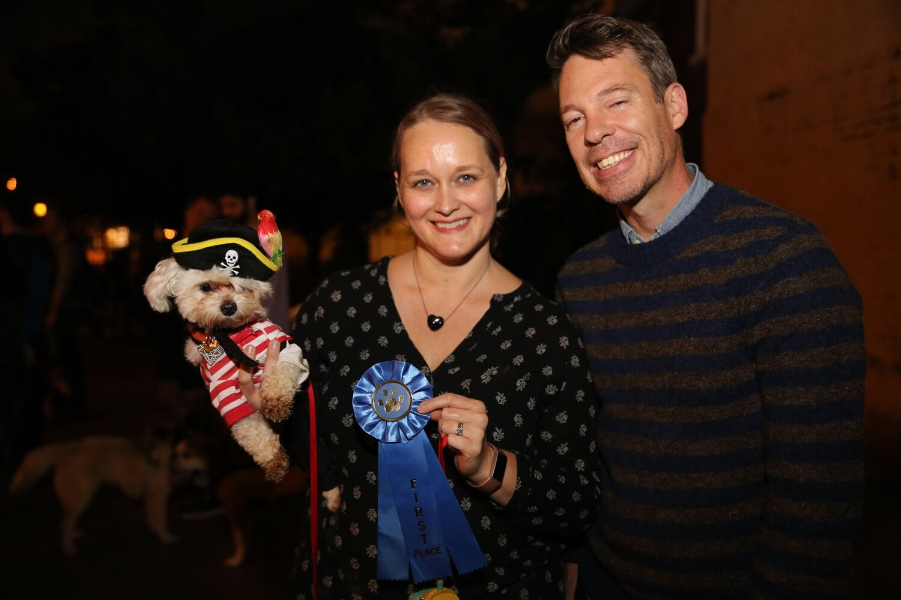
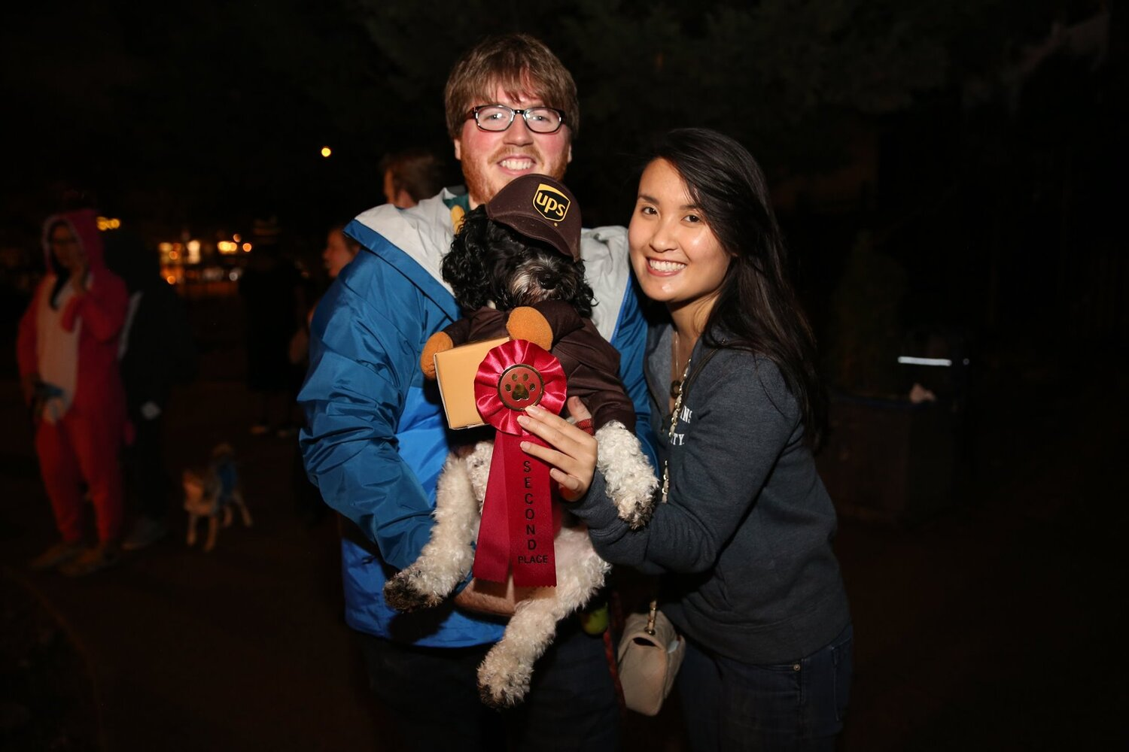

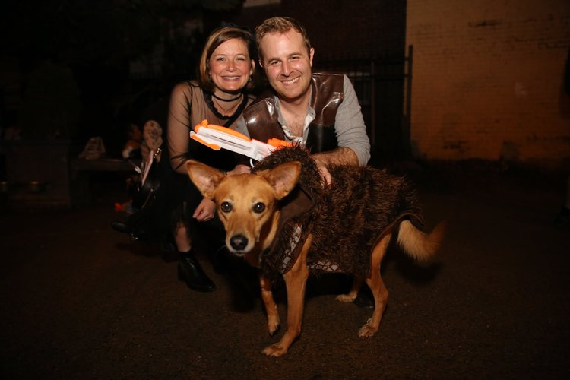
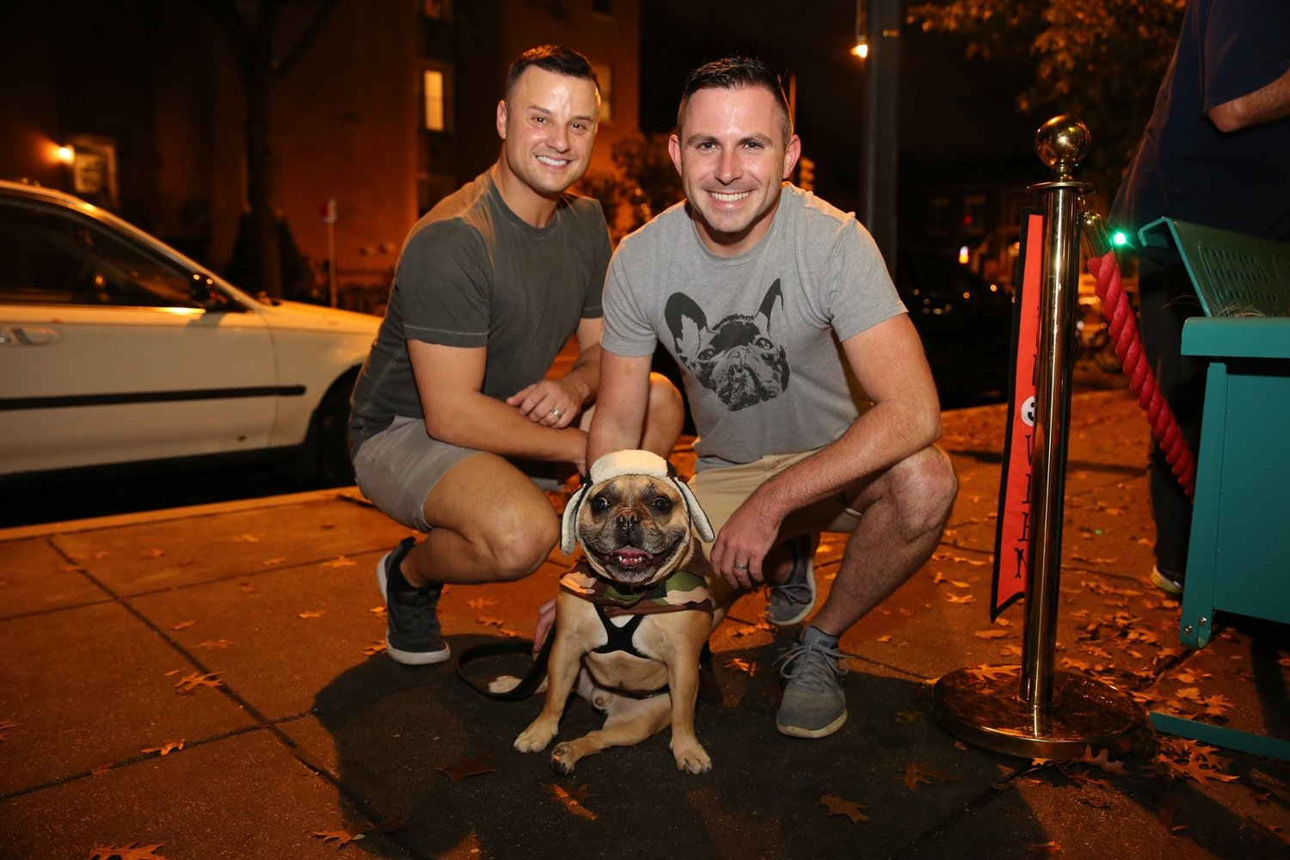

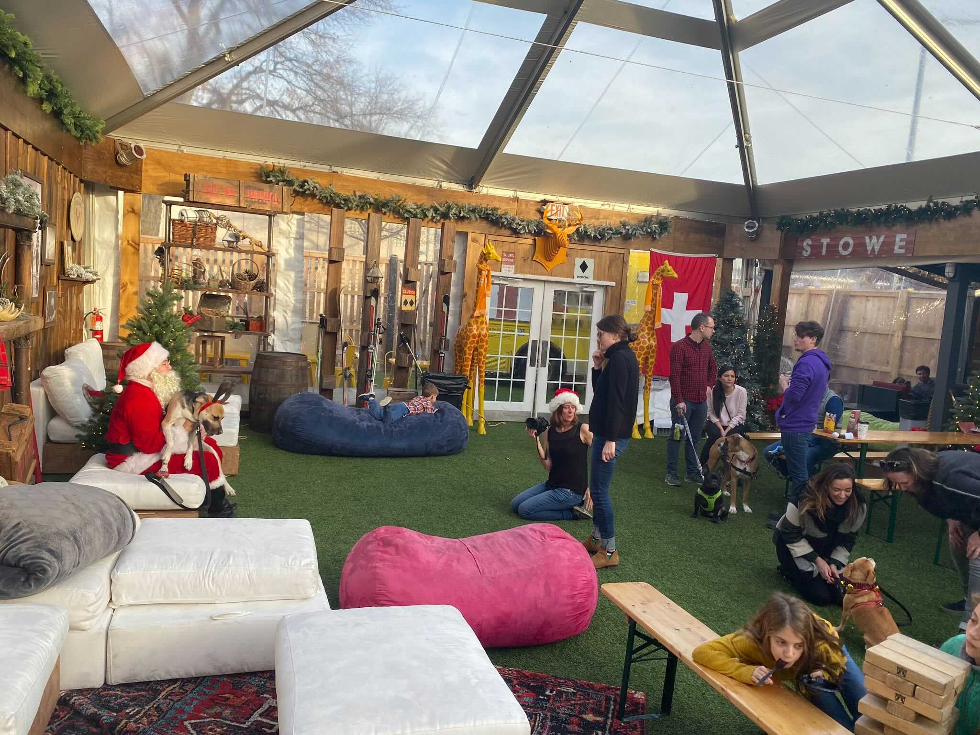
Pictures with Santa
Organizing another successful Dogs with Santa event. 41 dogs got to meet Santa and tell him their Christmas wish list and we suspect that many of the photos became their parent’s holiday cards. Georgia Avenue’s Hook Hall were amazing hosts, allowing us to set up our photoshoot in their backyard Swiss Chalet.

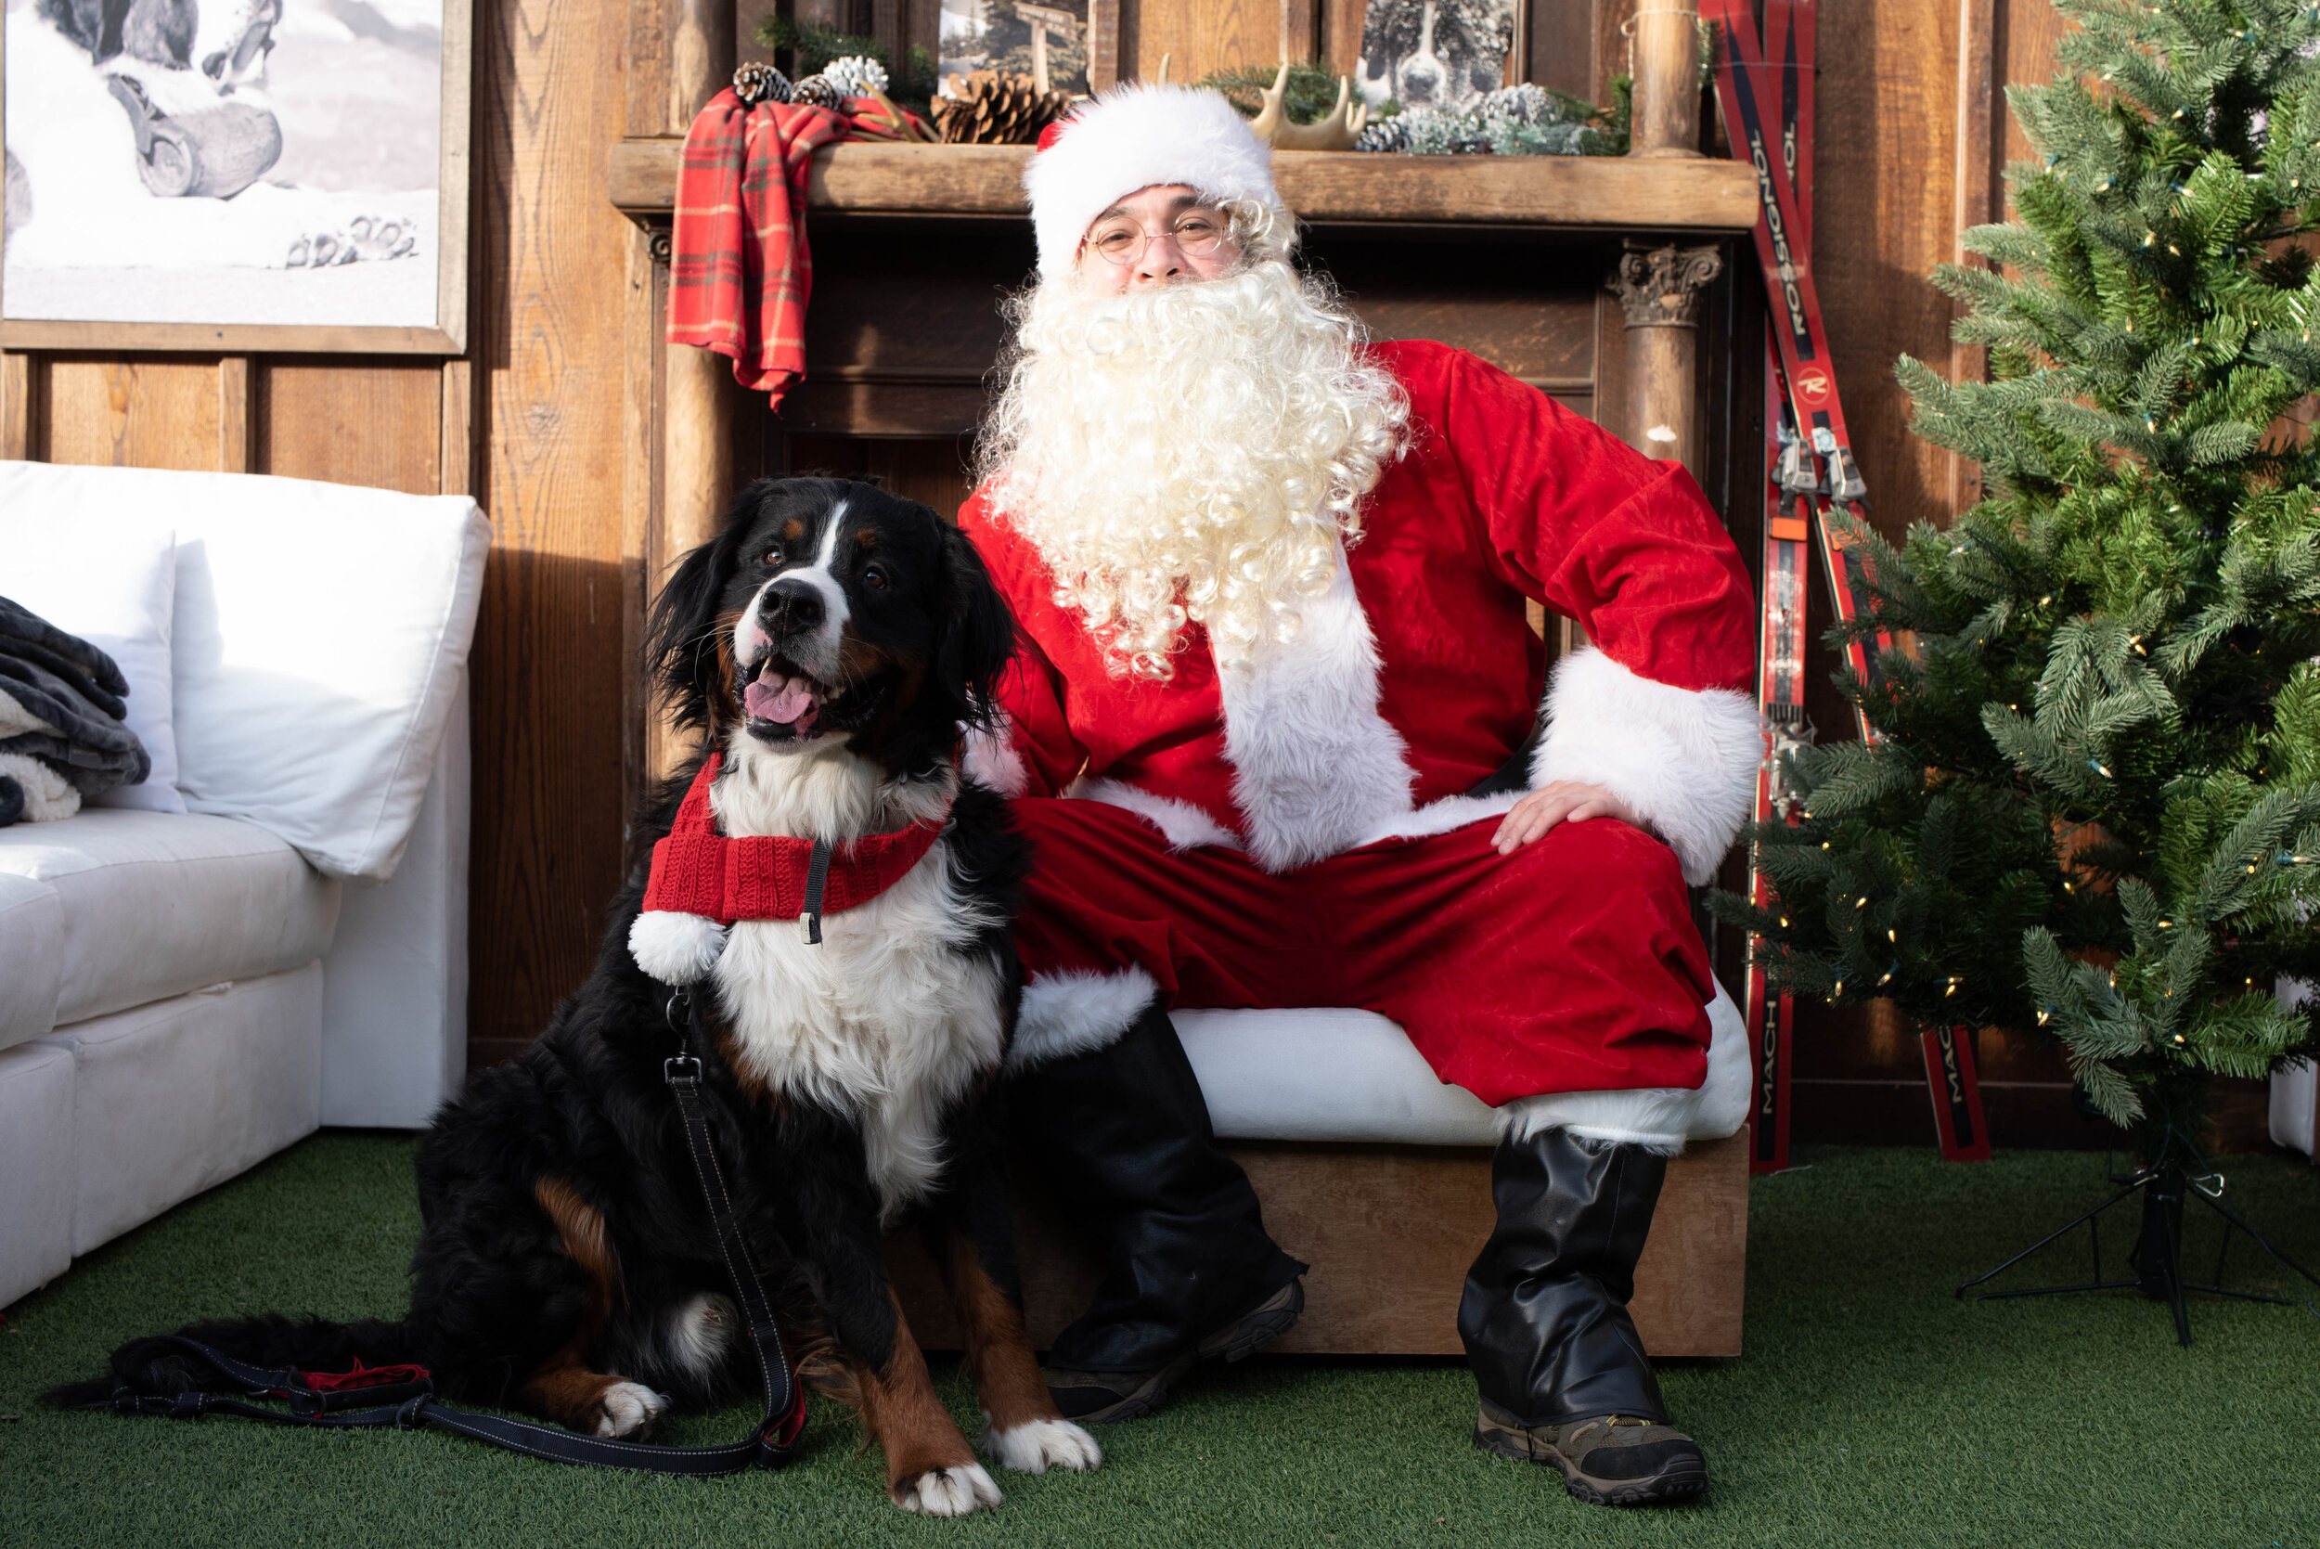
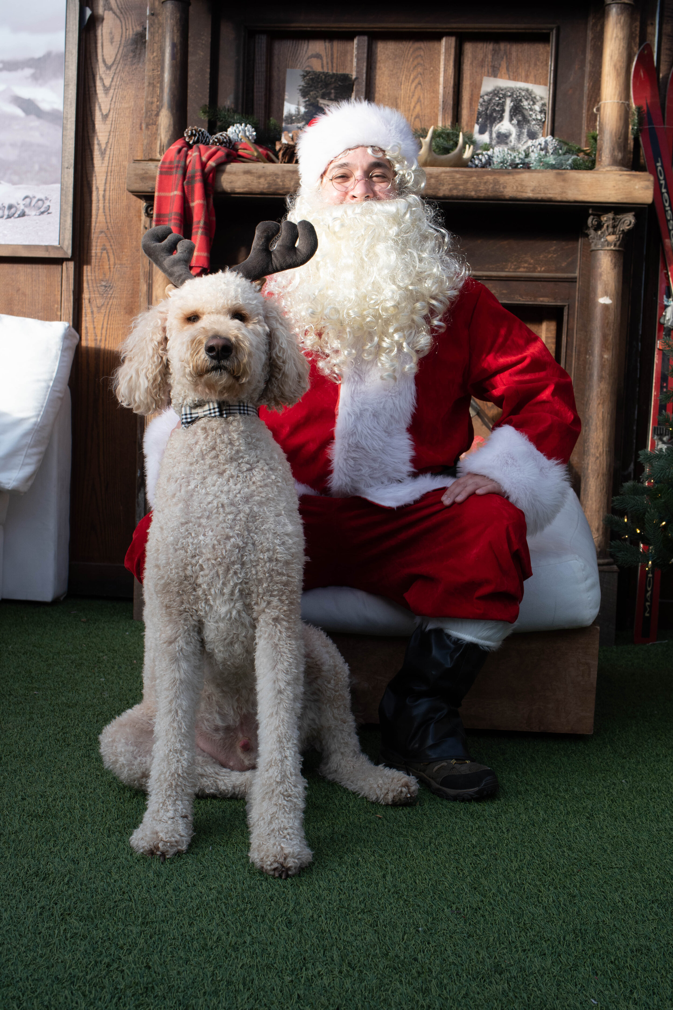
Cleanups
Holding quarterly cleanups at the park and joining the April Great CoHi Cleanup. As part of our cleanups in 2019, we replaced the mesh fencing to help keep the little dogs and tennis balls from escaping, picked up trash and dog waste, trimmed the trees, mowed and weed whacked the weeds, cleaned the tables and benches, and much more. 11th & Bark last year also officially adopted the blocks surrounding the park as part of the Mayor’s “Clean City” program. This means we do not just keep the dog park clean but we are a good neighbor and pick up trash outside the park during our cleanups as well.
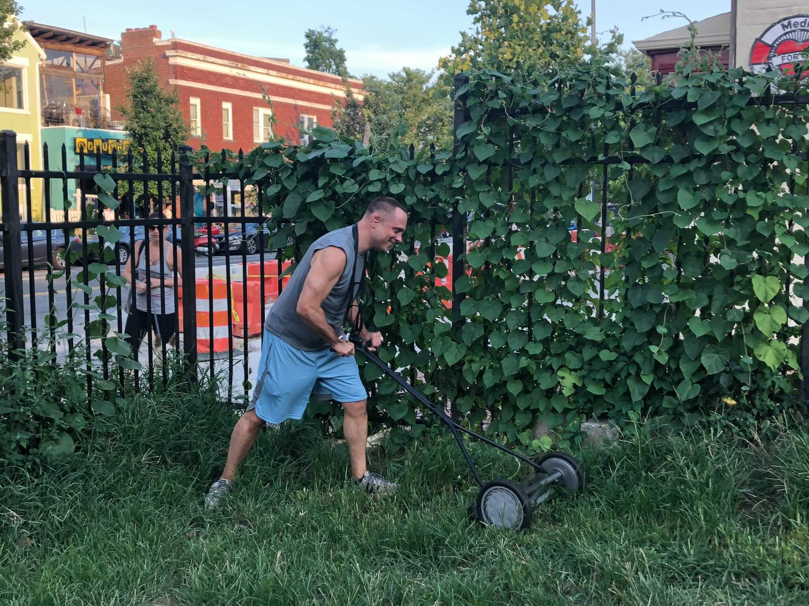
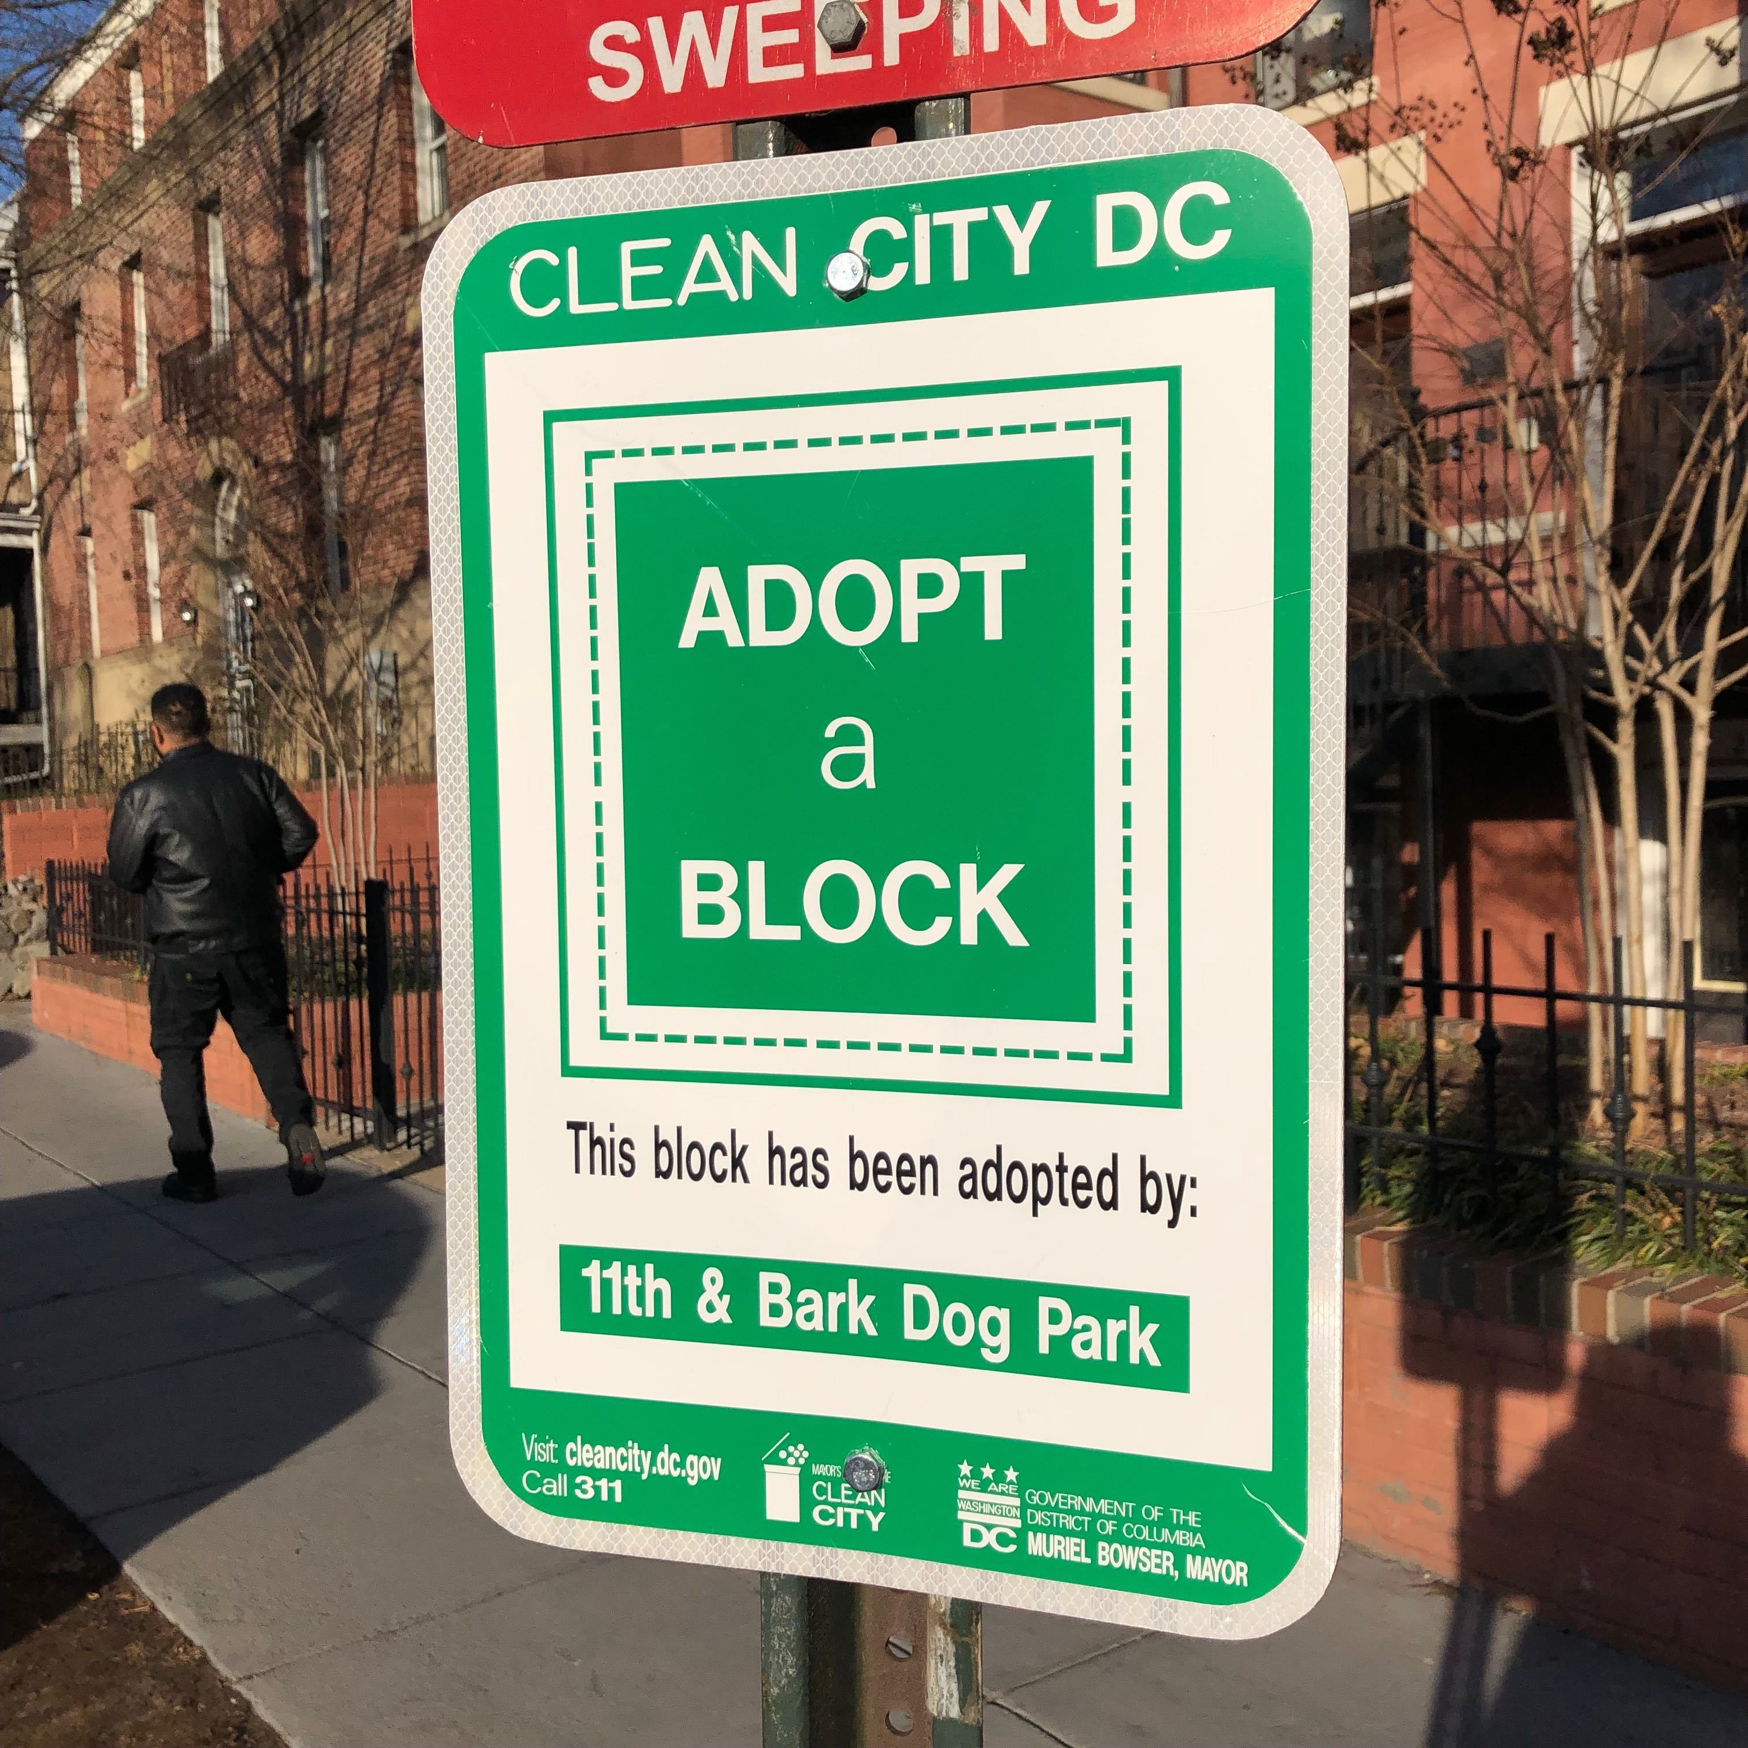
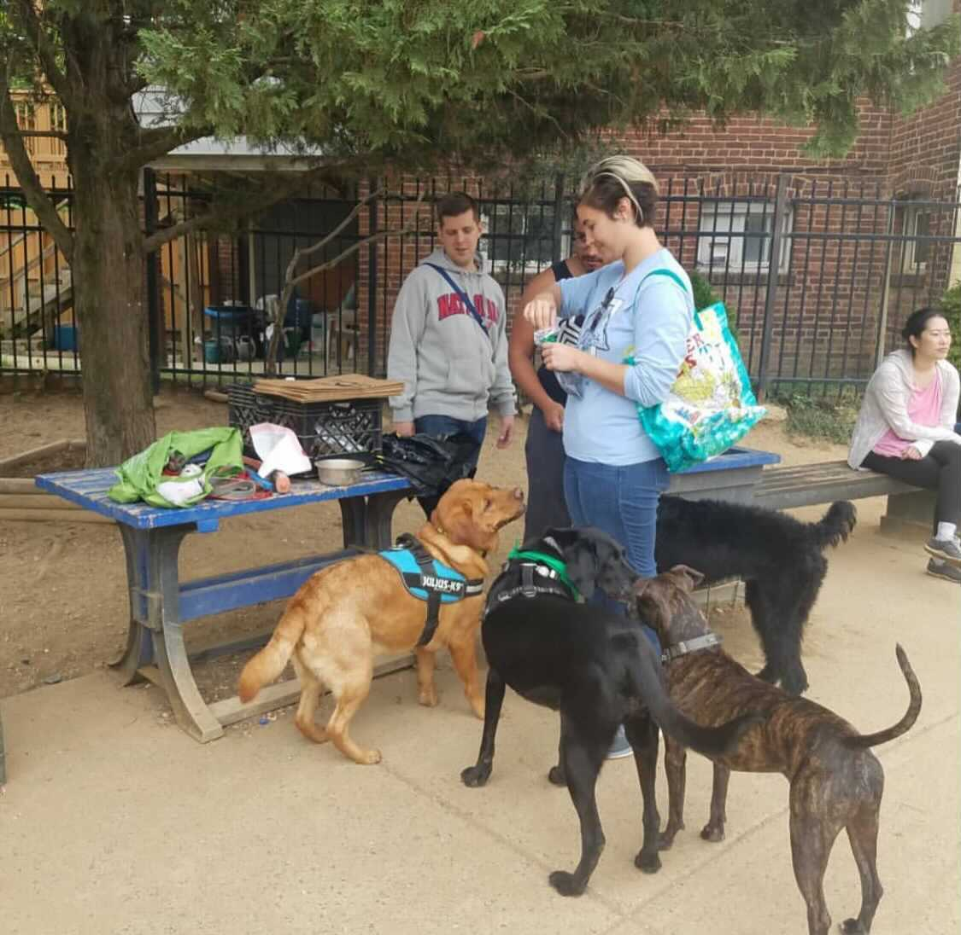
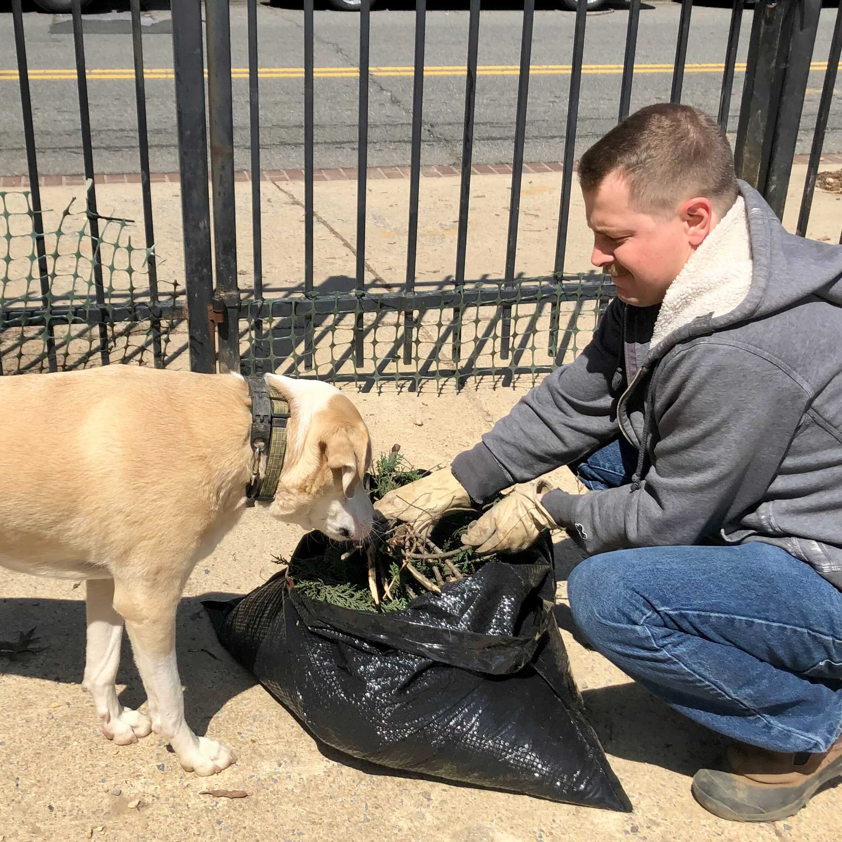
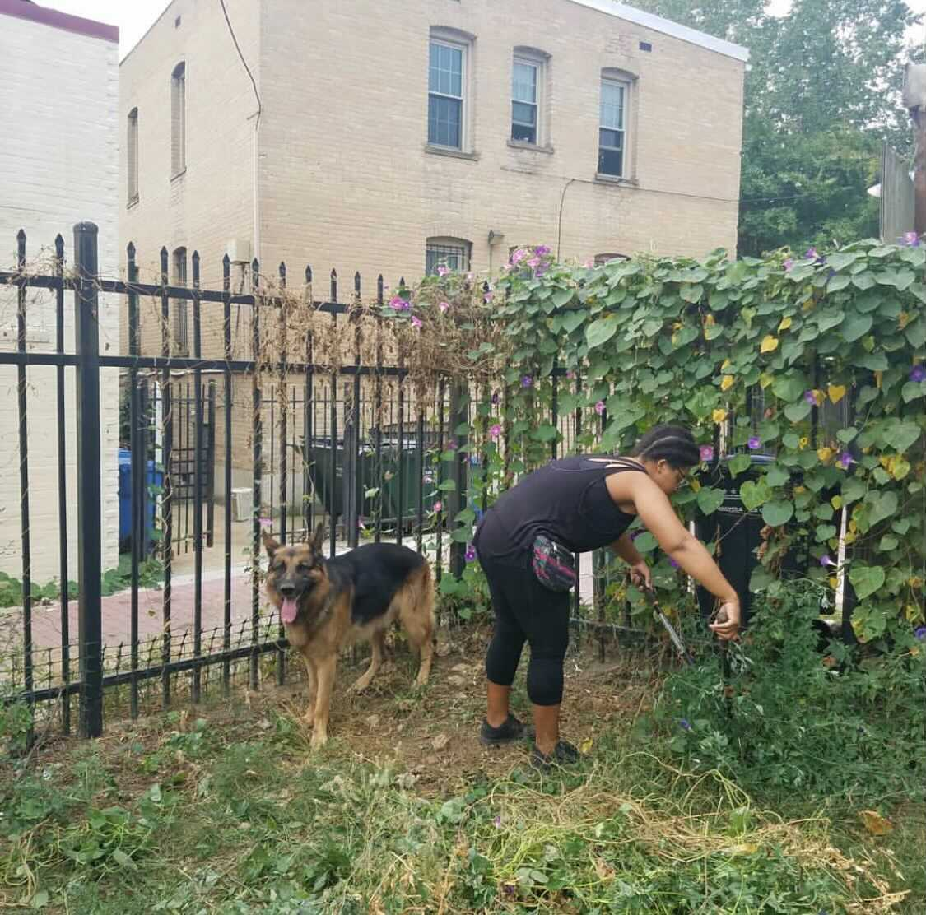

Connecting the Community
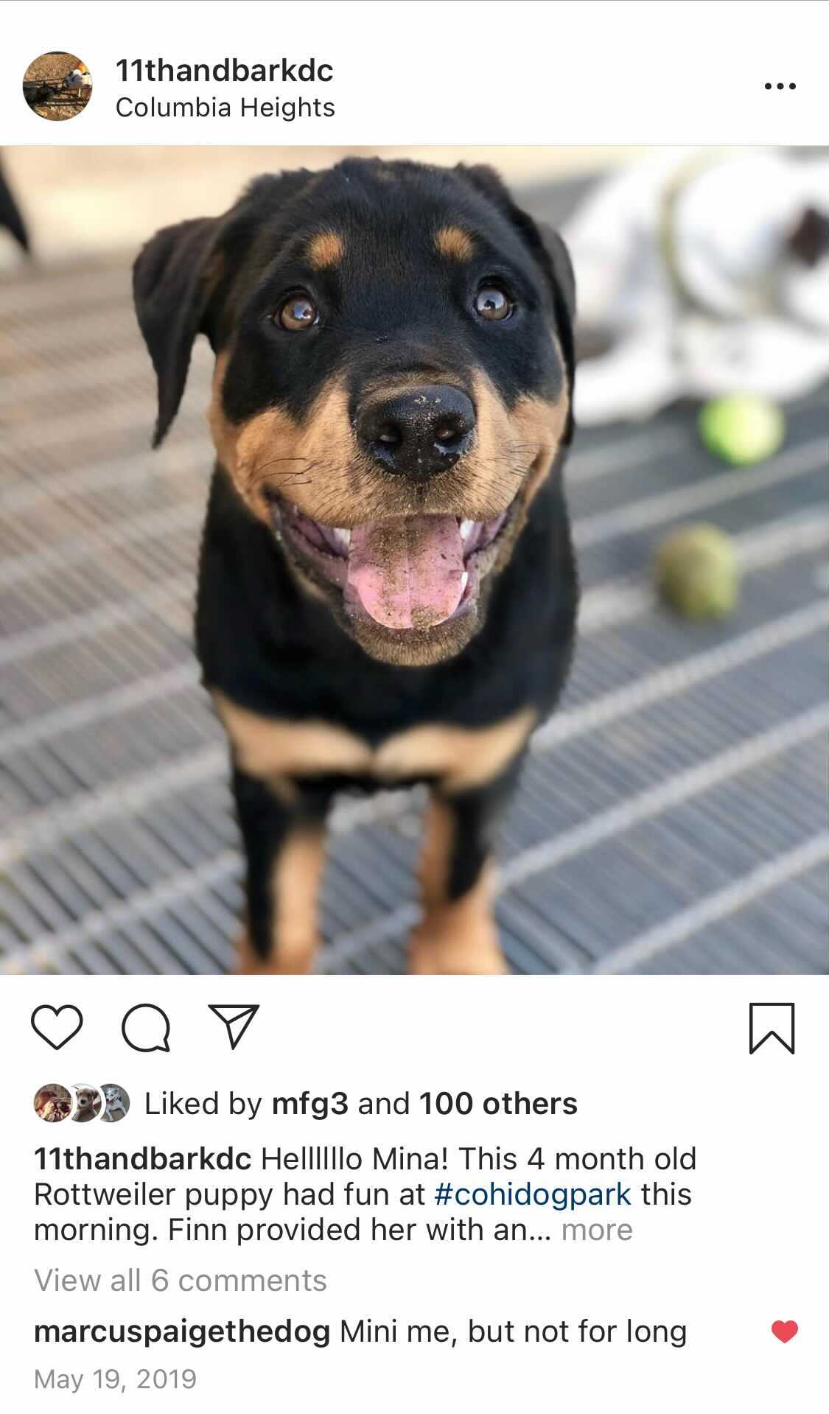

11th & Bark continued to update our website and maintain a continuously growing email list to keep dog park supporters and the community at large informed about the dog park and other community-related news. Our social media platforms, which continue to grow as well, are also used to provide dog park news and community information. In addition, these platforms allow us to connect with the greater Washington area pet rescue organizations by sharing posts about lost and found dogs and highlighting dogs up for adoption. In all areas of our work, we are committed to the dog park, but we are also to building community beyond the dog park gates.

Annual Meeting

We held our annual meeting on November 24th in the community room at District Bridges where we reported to the dog park community about the events of 2019 and what we anticipated happening in 2020. Council Member Brianne Nadeau; ANC1A Member and Chair of the ANC1 Zoning, Planning, and Parks Committee, Michael Wray; and ANC1A Angelica Castañon all attended and spoke. John Henderson of Green Spaces for DC also addressed the crowd.

Financials

Donations: $1,181.68

Expenses: $997.44

Annual management fee for Green Spaces for DC $300.00
Website expenses $248.96
Printing - postcards, signage $203.44
Office supplies - stamps, laminator, lamination sheets $79.05
Cleanup supplies- trash bags, zip ties, hand sanitizer $32.51
Room rental for annual meeting $100.00
Event supplies - ribbons, treats $33.48

We ended calendar year 2019 with $1348.80 cash on hand.

